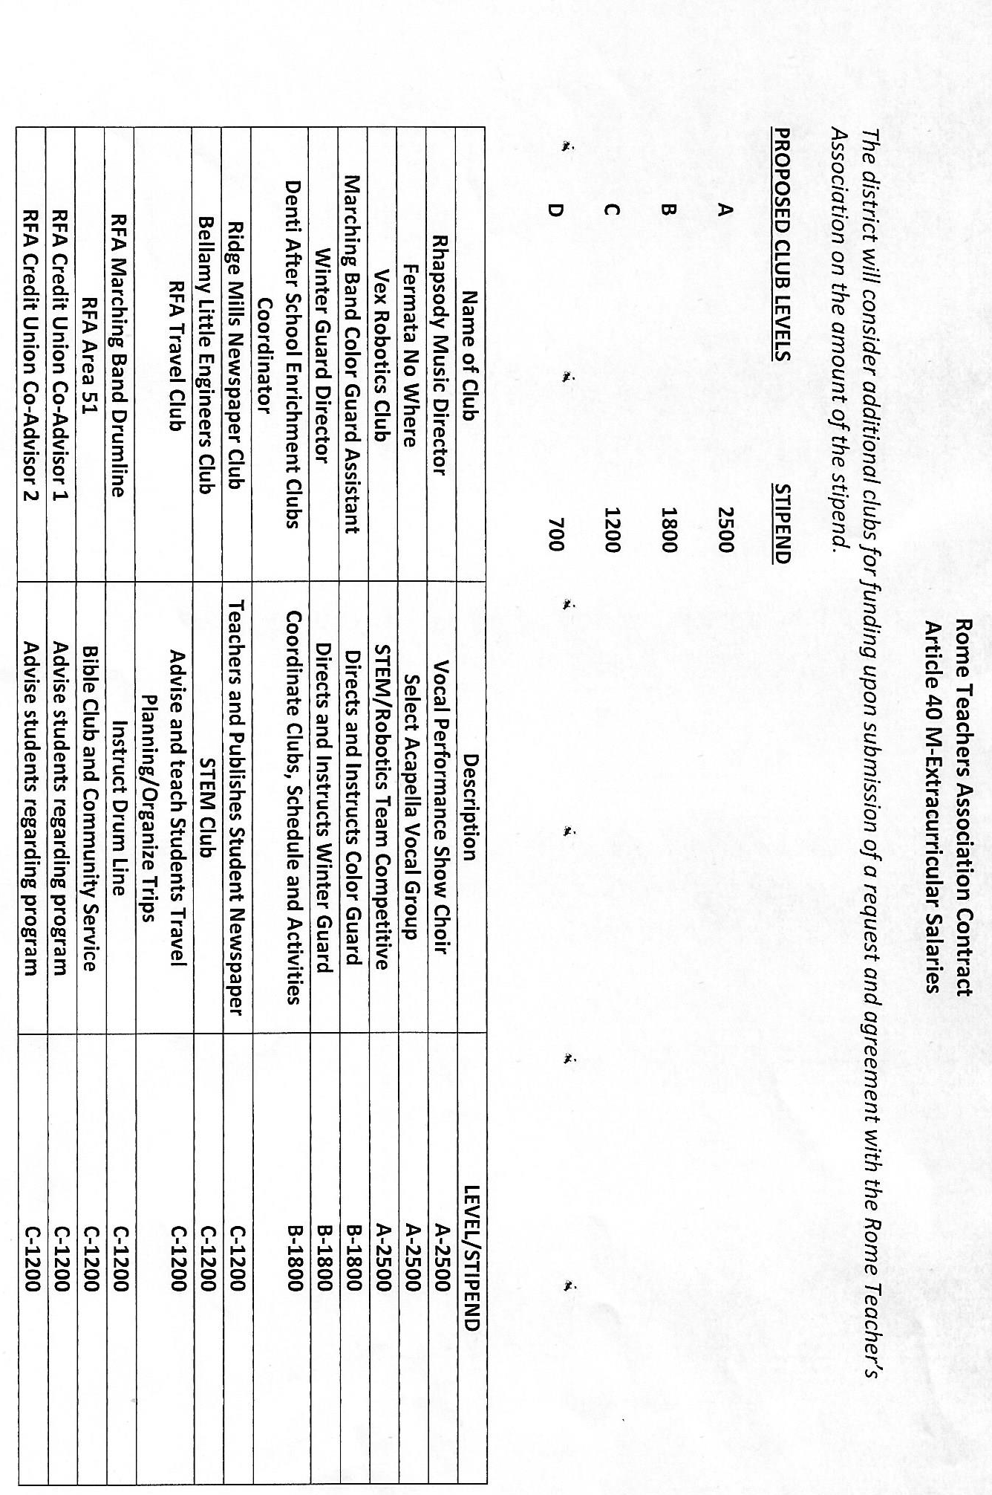

RFA Weightlifting Club |  | C - 1200
Strough Pep Band |  | C - 1200
Strough Jazz Band |  | C - 1200
Assistant Director STASS |  | B - 1800
Model Engineering Club-Co-Advisors(2) |  | D - 700

